Practical-4
Task-1
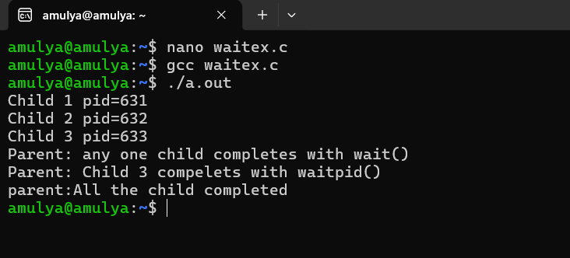

Task-2:
zombie.c
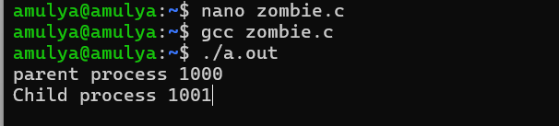
Terminal-2
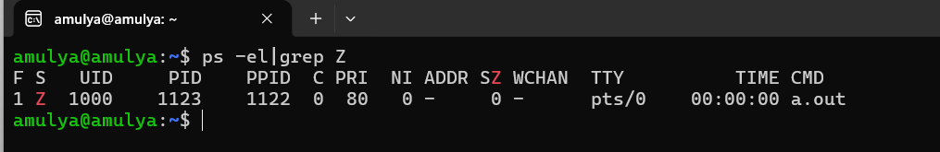

Eliminate zombie process
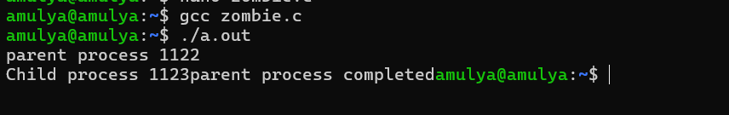
Terminal-2
